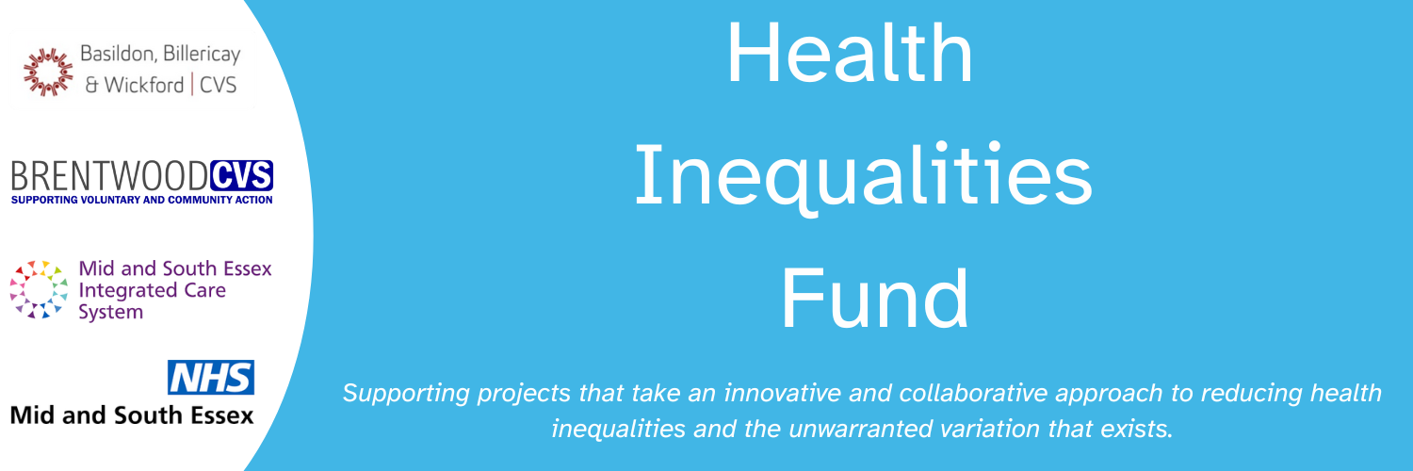

Basildon & Brentwood Health Inequalities Grant 2024/25

The NHS grant aims to address the challenges and obstacles faced by individuals dealing with health disparities. For detailed support guidance, please consult the provided resources. If you have any inquiries, kindly reach out to us via email at either funding@brentwoodcvs.org.uk or admin@bbwcvs.org.uk. All application submissions should be directed to these email addresses.

Section 1 Organisation Details
Name of Organisation
Type of Organisation (Registered Charity, CIC, faith group, etc)
Lead Contact Name
Phone Number
Contact email

Section 2 Your Project
What is the name of your project?
Brief description of the project (no more than 250 words)
Is this a new or existing project? Please indicate below.
New |  | Existing

Section 3 (Please complete if you answered EXISTING in Section 2 otherwise go to Section 4)
If this project is a continuation or extension, please provide further details e.g. when the project started and any other supporting information.

Section 4
How have you identified the need for this project? (no more than 250 words)

All projects must support one or more of these objectives. Please select which is relevant for your proposed project.

20% most deprived (Core 20)
Maternity in BAME communities
Severe Mental Illness
Chronic Respiratory disease
Early Cancer Diagnosis
Hypertension case finding
Smoking Cessation
Any other locally defined group subject to health inequalities (ie. homeless, those living with learning disability)
Other - please indicate below.

Please CLEARLY detail the project's intended outcomes and how these will be measured, including the number of beneficiaries (no more than 250 words)

Likely start and finish date of your project

Please provide a full breakdown of estimated costs to deliver your project. This may include venue hire, staffing (grade, role, hours), equipment, additional resources.

Please detail any in-kind support and its value (e.g. free venue hire, volunteer time, equipment use)

Please clarify how much funding you are applying for?

Have you received any match funding towards this project (if yes, who from and how much?)

Please detail how your proposed project will be sustainable after the end of the grant and what legacy will it leave. (no more than 250 words)

Are there any additional information not covered within the questions above?

Signature of applicant
Date

